

**Quest vRanger**

Contents

vRanger Configuration Checklist 2

Supported Collection Types 2

Data Sources 2

Requirements 3

vRanger Database 3

Connectivity to vRanger Server from Bocada Data Collection Server (DCS) 3

Setup 3

Server Properties 3

Field Definitions 4

Troubleshooting 6

Allowing SQL authentication access to the vRanger SQL instance: 6

Technical Support 7

# vRanger Configuration Checklist

While detailed steps are included below, this is an overview of the steps to configure vRanger collections on your Bocada Data Collection Server:

* Verify location of the vRanger database.
* If necessary, create a SQL login with Read access on that database.
* Verify locations of the log files, and access to that location.
* Verify required TCP port has been opened.
* Add the vRanger server to Bocada under Operations > Backup Servers, and set Server Properties.

# Supported Collection Types

The plugin currently supports the following collection types from vRanger servers:

|  |  |  |
| --- | --- | --- |
| **Collection Type** | **Supported** | **Description** |
| Backup* | ✓ | Collects transactional details about backup, duplication and restore jobs. Example metrics include, start times, durations, bytes, files, errors etc. |
| Storage |  | Collects point-in-time inventory information. Example metrics include, total recoverable gigabytes (storage), media volume count, media volume status, etc. |
| Policy |  | Collects and stores information on policy attributes, schedules, storage units, storage groups, storage lifecycle policies and clients. |

**\* Note:** The *VM Protection Analysis* report displays Virtual Machines (VMs) in the environment, showing data protection status (or lack thereof) for each VM, and will indicate if those VMs are protected by snapshots, backup applications, or are exposed as unprotected.  This feature is supported for several backup applications, including vRanger.

When both vCenter and vRanger Backup Servers have been added to Bocada, Backup updates on both will also correlate vRanger client data with vCenter virtual machine data, in the following scenario:

* The vRanger server backup client is a virtual machine managed by vCenter.
* The vCenter virtual machines have been added to Bocada data collection and previously inventoried using the vCenter plugin in Bocada.

# Data Sources

The plugin relies on the following vRanger data sources:

* vRanger database

# Requirements

This section lists requirements that must be met prior to collecting data with the Bocada plugin for vRanger.

### **vRanger Database**

The Bocada plugin requires access to the VRanger database with SQL or Windows Authenticated user that has permission to run SELECT queries.

### **Connectivity to vRanger Server from Bocada Data Collection Server (DCS)**

The Bocada Data Collection Server must be able to connect to the vRanger Server on the port(s) that the vRanger software responds to. By default, the TCP port is 1433.

# Setup

### Server Properties

Backup Server Properties determine how the plugin will interact with the vRanger server. Backup Server Properties are accessed from the Operations > Servers view:

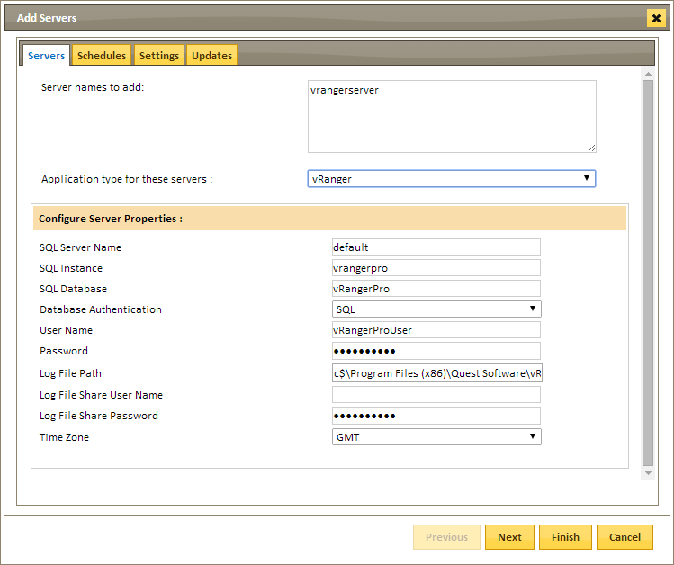

### Field Definitions

#### SQL Server Name

Provide the name of the server where the vRanger database resides, or leave as default if the database resides on the same server as the application of vRanger (defaults to name of server).

#### SQL Instance

Provide SQL instance where the vRanger database resides (defaults to ‘vrangerpro’).

#### SQL Database

Provide the name of the vRanger database (defaults to ‘vRangerPro’).

#### Database Authentication

Choose SQL or Windows Authentication depending on the type of User that will be used to access the VRanger database.

#### User Name / Password

Enter the credentials for the SQL or Windows Authenticated user that has permission to run SELECT queries against the VRanger database.

#### Log File Path

While optional, this setting allows for additional job messaging to be collected. The default path is: C$\Program Files (x86)\Quest Software\vRanger\Service\Logs\User.

#### Log File Share User Name & Password

Enter credentials that have access to the log files specified above.

#### Time Zone

Select the time zone where vRanger server resides. This setting ensures times are displayed consistently in environments that span multiple time zones.

# Troubleshooting

### Allowing SQL authentication access to the vRanger SQL instance:

These steps may be necessary if the default SQL user ‘vRangerProUser’ is locked down:

1. In SQL Server Management Studio, connect to the vRanger SQL instance (defaults to ‘vrangerpro’)
2. Enable SQL authentication (mixed mode):
   1. Right-click on the instance and select *Properties*
   2. In the Server Properties window that appears, select *Security*
   3. Under *Server authentication*, select *SQL Server and Windows Authentication mode*
   4. Click *OK*.
3. Add a new user with SQL authentication:
   1. In the SSMS Object Explorer, click on the plus icon next to *Security* to expand
   2. Right-click on *Logins* and select *New Login*
   3. In the new Login window that appears, on the General tab:
      1. Select the *SQL Server authentication* button.
      2. Enter the login name and a password which meets your password policy.
   4. On the Server Roles tab: Select the appropriate role.
   5. On the User Mapping tab:
      1. Select your vRanger database (defaults to ‘vRangerPro’)
      2. Select the appropriate membership roles (Read access should be sufficient)
   6. On the Status tab:
      1. Verify Permission to connect is *Granted*
      2. Verify Login is *Enabled*

# 

# Technical Support

For technical support or a copy of our standard support agreement, please contact us.

**E-mail:** [support@bocada.com](mailto:support@bocada.com)

**Support Portal:** <https://bocada-support.force.com>

**Phone:** +1-425-898-2400